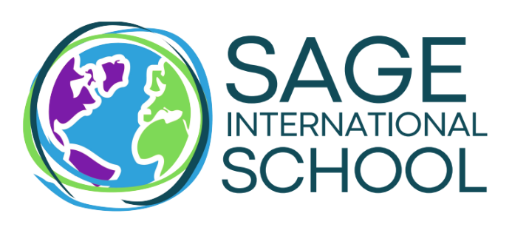
Middle School Teacher

Location: Sage Boise or Middleton
Grade: 6-9 / Middle Years Programme
Position: Certified- Full Time
Calendar: 2023-2024 academic year

Sage International School – Boise or Middleton - a public school of choice - is seeking applicants to fill a FULL TIME Secondary Teacher position for the 2023-2024 academic year.

Description:
Successful candidates will be certified to teach in public schools, either in Idaho or in another state with a willingness to transfer certification to Idaho. The position of Secondary School teacher at Sage International School requires that the successful candidate:

Qualifications:
- Develop and teach a curriculum for secondary school positions or electives.
- Demonstrate the IB Learner Profile attributes of Knowledgeable, Balanced, Thinker, Reflective, Communicator, Risk-Taker, Inquirer, Caring, Principled and Open-Minded
- Have a genuine love of working with children and an enduring interest in teaching, learning and student engagement
- Be a team player→positive, respectful, adaptable, and flexible, with good communication and collaboration skills
- Be familiar with and a believer in inquiry-based and project-based authentic learning
- Be comfortable with integrating instructional technology into lessons when applicable
- Be able and willing to work hard in a highly demanding program and to see differences and challenges as an opportunity for personal and professional growth

Salary and benefits package depending upon experience. Please review this information on the Sage International website to ensure a good fit of interest and educational philosophy.

Required:
- Certified Application
- Cover Letter & Resume
- Copy of Official Transcript(s)
- Copy of current Teaching Certificate(s) or date Certification will be obtained.
Please email application materials to jobs@sageintl.org.

***Sage International Network of Schools is an equal opportunity employer.***
NOTE:
All certificated and non-certificated employees and other individuals are required to undergo a criminal history check and submit to fingerprinting. Any applicant convicted of any of the felony crimes enumerated in Section 33-1208, Idaho Code may not be hired, and any applicant convicted of any felony offense listed in Section 33-1208(2), Idaho Code shall not be hired.

